Next Generation Science Standards
Eco Spheres
Grade 5

5-ESS2-1. Develop a model using an example to describe ways the geosphere, biosphere, hydrosphere, and/or atmosphere interact.
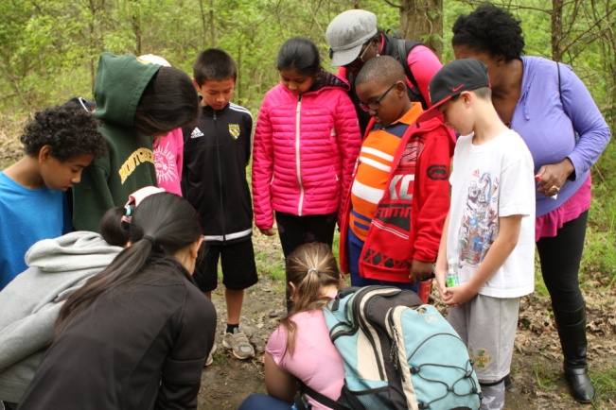

In this fun and engaging program, students will interact with several different models, looking for evidence that the spheres constantly interact. Then they will team up to design their own models back at school. At the Watershed Institute, we will begin with a review of the four spheres, and then take part in guided imagery before examining the models, which include a habitat hike, Enviroscape watershed model, and water cycle and migration simulation games. Then we will provide the criteria and constraints so they can develop their own model that shows how these spheres are constantly interacting.
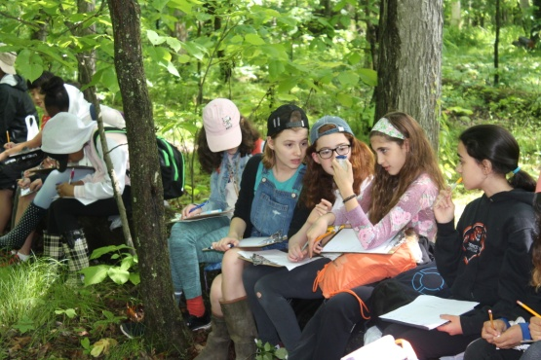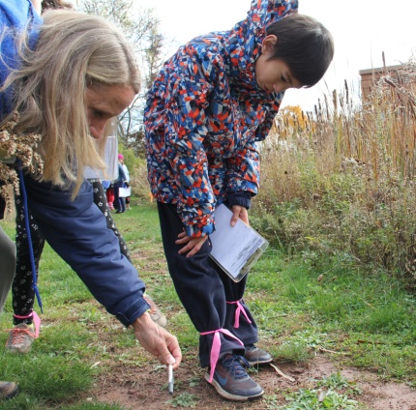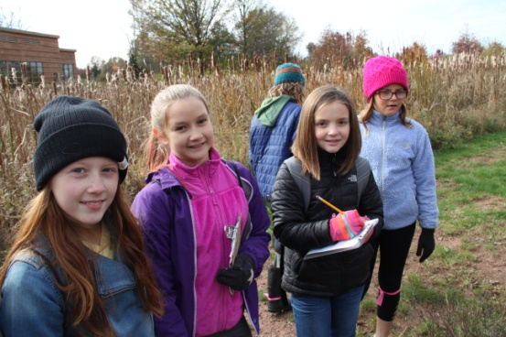

Science/Engineering Practice: | Disciplinary Core Idea: | Cross Cutting Concept:
Developing and Using Models  Develop a model using an example to describe a scientific principle. (5-ESS2-1) | ESS2.A: Earth Materials and Systems  Earth’s major systems are the geosphere (solid and molten rock, soil, and sediments), the hydrosphere (water and ice), the atmosphere (air), and the biosphere (living things, including humans). These systems interact in multiple ways to affect Earth’s surface materials and processes.  The ocean supports a variety of ecosystems and organisms, shapes landforms, and influences climate. Winds and clouds in the atmosphere interact with the landforms to determine patterns of weather. (5-ESS2-1) | Systems and System Models  A system can be described in terms of its components and their interactions. (5-ESS2-1)

