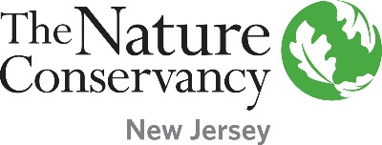
Grant Application
Modified Project Action Plan

Please use this form to outline the specific steps needed to complete the proposed project. It should begin with the key planning tasks and end with the completion of the final grant report. Per the terms of the grant, the project needs to be completed within the grant performance period. Plans to remove invasive species must be included in this timeline and show that this process will not prevent the project from being completed within the grant performance period. Invasive species removal can begin before the grants are awarded and is the financial responsibility of the applicant. Community engagement steps can include plans to use volunteers to complete the project. Project promotion steps can also include any plans to issue press releases.
Steps/Tasks that the Project Team will take to Complete the Proposed Grant Project | Team Member Responsible | Target Completion Date
Planning Steps
1.
2.
3.
Invasive Species Removal (If Applicable; Can Occur Before Grant Is Awarded)
1.
2.
3.
Implementation Steps
1.
2.
3.
Community Engagement Steps
1.
2.
3.
Evaluation and Reporting Steps
1.
2.
3.

Project Promotion – Events Where Promotional Materials With Sponsor Recognition Are Distributed
Name of Event | Materials | Date
1.
2.
3.
Proposed Date of Ribbon Cutting Ceremony (If Applicable)

