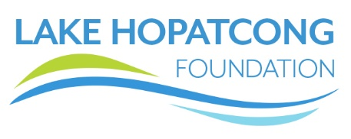
Job Profile – Executive Director
Overview: The Lake Hopatcong Foundation seeks an Executive Director who would bring passion for our mission and strong leadership to our organization, building upon the excellent reputation developed in our communities in the initial 8 years since its creation. As we look to the future, our next Executive Director will be a highly energetic individual with excellent communication skills, an ability to motivate staff and volunteers, and be effective in representing the Foundation and collaborating with the various constituents we serve in the Northern New Jersey area.
Status: This is a full-time position. Salary commensurate with experience level. Health and retirement benefits are available.
Mission: The Lake Hopatcong Foundation dedicates itself to protecting the lake environment and enhancing the lake experience, bringing together public and private resources to encourage a culture of sustainability and stewardship on and around New Jersey’s largest lake, for this and future generations.
Organization Description: The Lake Hopatcong Foundation is a growing 8-year-old nonprofit organization that is based on New Jersey’s largest lake and works to improve and enhance the lake environment and experience. We do this through:
- Environmental initiatives that protect water quality and prevent invasive species
- Educational initiatives that teach local students about watersheds, lake ecosystems, history, and safety
- Safety initiatives that help reduce recklessness and accidents on the water
- Recreational and community-building initiatives that help bring together the four towns and two counties that surround Lake Hopatcong
Summary of Responsibilities: The Executive Director is responsible for the overall leadership and administration of the Lake Hopatcong Foundation, including managing the staff, being a liaison to the board of trustees, and serving as the public face of the organization. The Executive Director establishes and monitors the organization’s budget, works with the board to execute the strategic plan, participates in outreach to officials, groups, and coalitions that support the LHF mission, and plays a key role in fundraising and attracting donor support. Guiding and building upon the various programs that the Foundation creates and maintains will be a key responsibility of the Executive Director, including supporting a large team of volunteers that work with us. Learn about our programs at www.lakehopatcongfoundation.org.
Experience Required: Several years of leadership experience, preferably in the nonprofit sector, is required, with a proven track record in guiding an organization to attain and exceed goals, which includes fund development as well as program execution successes. Experience in one or more of our mission areas: environmental science, public safety, education, and community building, as well as local, county, or state government is desirable, as is a passion for the outdoors and issues pertaining to lakes and watersheds.
Please reply to: http://lake-hopatcong-foundation.breezy.hr/p/211d3944de88-executive-director

