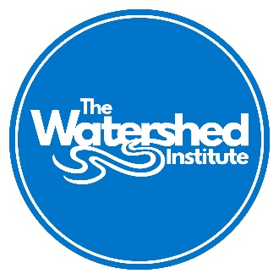 | 2021-2022 Watershed Institute Grant Program  Project Grants Letter of Inquiry (LOI) Form
Type your responses into this document form and save the file. Email the saved form to poliveira@thewatershed.org with “[your organization’s name] LOI” in the subject line, along with scanned copy of the IRS determination letter that confirms your organization’s 501(c)(3) tax-exempt status by 5 p.m. on August 6, 2021. If you can’t find a copy of your determination letter, call the IRS at 877.829.5500 and plan ahead as it may take weeks to receive a new one. Visit The Watershed Institute’s website (www.thewatershed.org/current-institute-grant-cycle) for the grant program description and eligibility requirements.

If you have any issues or concerns emailing your LOI, please contact the Outreach Specialist for mail-in instructions.

Name of Applicant Organization: |  |  |  | Federal Tax ID Number:
Mailing Address: |  |  |  | Phone Number:
City: |  | State: | Zip: | Email Address:
Name and Title of Principal Contact: |  | Website:
Title of Project (max 10 words):

Amount of WI Grant Funds Requested (max. $8,500): | In-kind Matching, estimated dollar value (encouraged but not required): |  |  | Total Project Cost:
Organizational Values: Has your organization committed to Justice, Equity, Diversity, & Inclusion related work and practices? Does your organization have a focus on serving the needs of people of color and under-represented and under-resourced communities? If so, briefly explain how. (Max 500 words)

Goal: What is the goal of this project? List a maximum of 3 goals. If applicable, briefly explain how this project’s goals address environmental justice related issues and/or work to inform, engage, and create more sustainable communities?

Need: Explain the environmental and/or community need for this project. Describe how it is different than similar programs and/or how it will build on existing programs, if applicable. (Max 250 words)

Eligibility: How does this project implement the Actions listed in the Grant Program Announcement? Specify the relevant Action/s. (Max 150 words)
Budget Description: Briefly describe the major components of this project for which you are requesting funds (e.g., staff time, printing costs, travel costs, project supplies, etc.). (Max 150 words)
Work Plan: Include a brief timeline (bulleted list) of project activities between Dec. 3, 2021 – Dec. 9, 2022. For example, meet with planning committee – Jan. 2022., Prepare campaign brochures – April 2022., etc.

Mission: Briefly describe the mission of your organization and how this program fits into this mission, as well as existing programming your organization offers (if applicable).

Outputs: List 1 - 3 specific direct results from the above activities. Use bullets. For example, # of events held, # of anticipated participants, etc.

Outcomes: Who (the environment, your organization, and/or an identified audience) is expected to change because of this project and how? List 2 - 3 outcomes. For example, event participants will have increased understanding of green infrastructure maintenance (short-term), or our organization’s future restoration plans will consider climate change impacts (long-term).
Name | Signature | Title | Date
Signature: (person authorized to enter into grant agreements on behalf of organization, e-signatures accepted)

If you have questions about this application, eligibility, etc., contact The Outreach Specialist at:

Priscilla Oliveira
Email: poliveira@thewatershed.org
Phone: 609.737.3735 x27
The Watershed Institute
31 Titus Mill Road
Pennington, NJ 08534

